Scope :
This Software Architecture Document provides an architectural overview of the RFM client. The RFM client software is designed to interact with the RFM server application running on the Quadcopter.
Definitions/Acronyms/Abbreviations

Software Architecture Representation:
This document presents the architecture as a series of views 1. Use case view 2. logical view 3. Process 4. deployment view. These are views on an underlying Unified Modeling Language (UML) model developed using Smartdraw.
Architectural Gaols and Constraints:
Few of the key requirements are mentioned below –
- RFM Client should be able to provide the secure mechanism to login to the RFM server using credentials over WiFi
- Once login is successful RFM client should meet the following requirements
- It should be able to transfer the PA to RFM server over WiFi network. RFM client should display error if any while transferring the PA on GUI.
- RFM client should be able to request the verification of PA (verification using digest checks and authentication using public keys) and in turn request uploading the required PA data to FC
- RFM client should be able to retrieve the existing PA from RFM server.
- RFM client should be able to retrieve the public key of the RFM server for verification of the logs
- Client application should be able to retrieve the logs from RFM server
- RFM client should be able to retrieve the RFM info (drone ID as of now)
- RFM client should be able to display the detailed errors on GUI for every operation if any
Use Case and functionalities of the entities:
In case of RFM, user is Pilot who has valid credentials to log in to the system and get the access to all the functionalities of the RFM server.
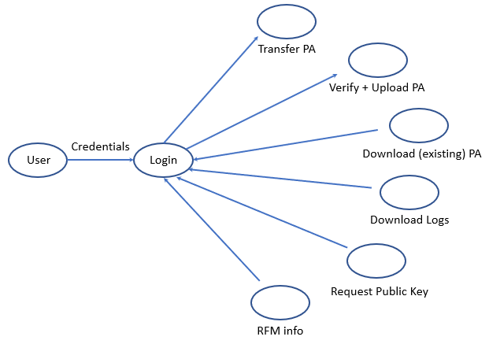
Login : User(pilot) login to the system to have access to all the functionalities related to the RFM server.
Transfer PA: This button allows pilot to transfer/store the PA to the RFM server.
Verify PA: This button allows pilot to initiate the verification and authentication process of the PA which in turn initiate the data upload process to the FC.
Download PA: This button allows pilot to get the existing PA from RFM server.
Download Logs: This button allows pilot to download the logs from RFM server.
Request Pub Key: This button allows pilot to get the public key of the RFM server which can be used for sending it to the concerned parties for verification and authentication.
RFM Info : This button click gives the information about RFM server such as Drone ID
Logical View:
Application layer:
This layer has the boundary classes which represents the buttons and texts on GUI. It consists of the timer functions which run at specific frequencies to process the requests and commands from GUI window
GUI Services:
This consist of the form to design the GUI consisting of buttons, texts and labels. This consist of controller classes that represents the use case of application layer.
Middleware :
This layer supports the access to network classes, xml classes and core GUI classes in Qt (TCP)

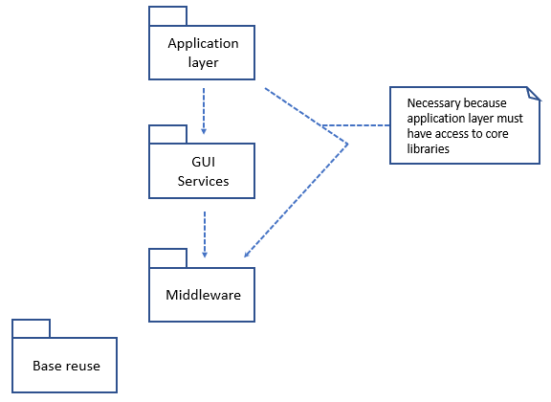

Process View:
Before clicking any button, pilot must make sure that machine on which RFM client is running should be connected to RFM server over wi-fi otherwise any button will throw error on GUI asking to connect to server first. RFM server act as wi-fi access point with the name Asteria_RFM. The figure below shows the RFM client GUI application window where red circle indicates the client is not connected to server.
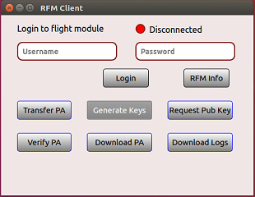

- RFM Server login
When application runs, it will not be connected to the RFM server by default. User/pilot must get the access for all the functionalities by entering the valid credentials i.e. username and password. The figure below shows the functionality calls for login button click
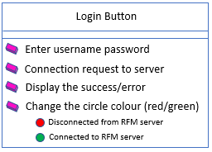
Workflow : When pilot enter the credentials, those credentials are verified by the application layer. If username and password is correct then, client will send connection request to the server. If RFM server is running, then GUI will show the success window else it will show error message. Following figure shows the results/errors if any for each operation
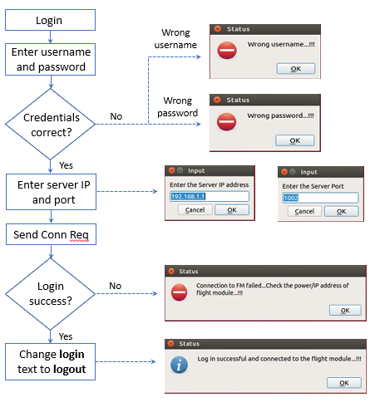
If login is successful, then GUI will look like as shown in the figure below where green circle indicates the state of connection to the RFM server.
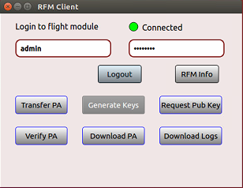
- Transfer PA:
Assuming RFM client is connected to the RFM server with valid credentials. Transfer PA button click will open the windows explorer to select the corresponding PA file. Following figure shows the functionality for the transfer PA button click.
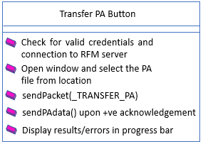
Workflow: When pilot clicks on Transfer PA button, GUI open windows explorer to select the PA file from corresponding location. According to the response from RFM server, client shows the result/error status on GUI. Following figure shows the results/error if any for the operation.
